**Lab 4: M/M/1**

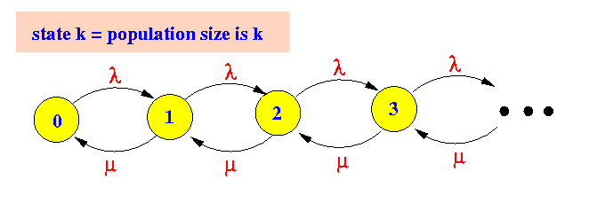

**Analyse the following problems in groups,**

1. In Lecture 5, page 15, based on the results, as the manager, is it better to hire another repair man or buy another machine in order to improve the productivity?
2. An Example of M/M/1 Queue
   1. An airport runway for arrivals only
   2. Arriving aircraft join a single queue for the runway
   3. Exponentially distributed service time with a rate u= 27 arrivals / hour
   4. Posisson arrival with a rate *λ* =20 arrivals/hour.

Question: What are the values for W, L, Wq Lq?

1. Now suppose we are in holidays and the arrival rate increases *λ* =25 arrivals/hour. How will the quantities of the queueing system change?
2. Customers arrive in a usual M/M/1 system, with an arrival rate λ and service rate μ. However, in some system, the customers in the queue are impatient: Each customer waiting in the queue will abandon the system without receiving service with a rate γ. Draw the Markov Chain diagram for this queue and derive the stationary probability πi in this chain.

**Submission**:

Summarise all the answers on a one-page document (per group). Your report can cover the following details but not limited to:

1. Your group member, responsibility of each team member and contribution in percentage.
2. Answers for Question 1, 2, 3 and 4.

**Deadline**: 1st November 2018

**DO NOT copy and paste from online resources.**